**Conestoga**

14

**Results**

**ASQL Final Project**

**Nick W, Constantine G, Jim R**

Table of Contents

Transformation Requirements (15) 3

Overall 3

i. Fahrenheit to Celsius (5) 3

ii. Inches to Millimeters (5) 3

iii. Parse YearMonth (5) 3

Data Visualization (20) (1-1.5 pages) 4

Libraries 4

General Approach 4

Series - PCP, CDD/HDD, TAVG/TMIN/TMAX 4

Region 4

Summary Data - Yearly, Quarterly, Monthly 4

X/Y Range 4

Time Slider 4

Printing 4

Schema Diagram (20 - includes appendix of scripts below) 5

Appendix A - SQL Scripts 6

# Transformation Requirements (15)

## Overall

The ETL was done within the asp.net application, which was then bulk uploaded into the database.

## Fahrenheit to Celsius (5)

In order to convert the Fahrenheit to Celsius, we use a single line within the application.

return ((fah - 32) * 5.0M / 9.0M);

## Inches to Millimeters (5)

In order to convert the Inches to Millimeters, we use a single line within the application.

return inches / 0.039370M;

## Parse YearMonth (5)

In order to parse the month and the year from the same string, I use a try parse for each on a substring of the input.

bool returnVal = true;

if(!Int16.TryParse(input.Substring(0, 4), out year))

{

returnVal = false;

}

if(!byte.TryParse(input.Substring(4, 2), out month))

{

returnVal = false;

}

return returnVal;

# Data Visualization (20) (1-1.5 pages)

## Libraries

* Google.Visualization
* ASP.NET

## General Approach

### Series - PCP, CDD/HDD, TAVG/TMIN/TMAX

In order to plot a series you need to pass the stored procedure a reference to which graph you want to put on the screen.

### Region

In order to plot a series for a specified region, you must select a region from a dropdown menu of possible regions you can view, this is passed in along with the series requested.

### Summary Data - Yearly, Quarterly, Monthly

In order to plot summary data, you must select the corresponding radio button. This is passed in along with the series and region requested.

### X/Y Range

Google.Visualization provides a chart that dynamically sets the X and Y ranges to reasonable numbers.

### Time Slider

The time slider is provided by Google using Google.Visualization.ChartRangeFilter. It allows the user to select a start and an end date.

### Printing

To print, we used a PDF writer.

# Schema Diagram (20 - includes appendix of scripts below)

## Schema with a Single User

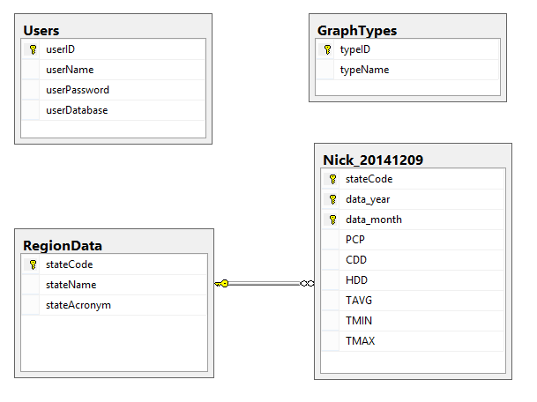

# Appendix A - SQL Scripts

// scripts